Chapter 9
Understanding and Constructing Cinematic Language:
Camera Movement and Camera Support
Static Shots versus Moving Shots
The decision to use a static shot versus a moving shot—such as a tracking, dolly, or handheld movement—has a profound effect on storytelling, tone, and the way an audience perceives a scene. A static shot, with its fixed perspective, conveys stability, control, and focus, while a moving shot introduces fluidity and energy, pulling the audience into the scene by replicating natural movement or shifting points of view.
In the earlier chapters on Understanding and Constructing Cinematic Language, our primary focus has been on static shots where the camera remains still for the duration of a shot, without any movement. This is achieved by locking a camera to a fixed position typically with a tripod or fixed mount. One of the main advantages of using a static shot is, it provides complete control over the detailed mise-en-scène, enabling precise framing, composition, and blocking while also allowing for stylistic choices like symmetry. Directors such as Wes Anderson typically employ static shots with symmetrical compositions to create a distinctive visual style. The Grand Budapest Hotel, Moonrise Kingdom, The Royal Tenenbaums, and most recently The Phoenician Scheme are just a few of his movies where he uses this approach to emphasize the films’ typical whimsical tone and intricate world-building
With static shots we also allow the audience to concentrate fully on the subject without distraction. This can be particularly effective in highlighting an actor’s performance when the viewer’s attention can be drawn to subtle facial expressions, body language, and emotional nuances. Similarly, in dialogue-heavy shot-reverse-shot sequences, where visual consistency and clarity between characters are crucial, static shots help keep the conversation as the central focus.
Example: No Country for Old Men (2007) – In the scene between Anton Chigurh and the gas station attendant, the camera remains completely static, with no movement throughout the exchange. This fixed perspective intensifies the unease of the moment, forcing the audience to remain locked in the tension of the dialogue without the relief or distraction that camera movement might provide. The lack of motion mirrors the suffocating inevitability of the encounter, amplifying both the menace of Chigurh’s presence and the helplessness of the attendant.
Our main emphasis in this chapter however, will be on camera movement and moving shots. We will be examining how shifts in the camera’s position or angle within a shot can do more than simply modify the frame and perspective. We are going to understand how camera movement can subtly and effectively enhance the cinematic language and guide our audience’s attention to ensure a seamless and immersive viewing experience. In that sense, we are going to recognize that camera movement not only enhances visual storytelling, but it also influences the emotional and psychological impact of a scene and contributes to narrative depth.
Camera Movement and Storytelling
As we talked about earlier, moving the camera with purpose helps guide the viewer’s attention and makes the experience feel smooth and immersive. In this section, we will break down common types of camera movement—such as pans, tilts, tracking shots, and handheld shots—and explore how each one helps tell the story, connect us to the characters, and add visual impact to a scene.
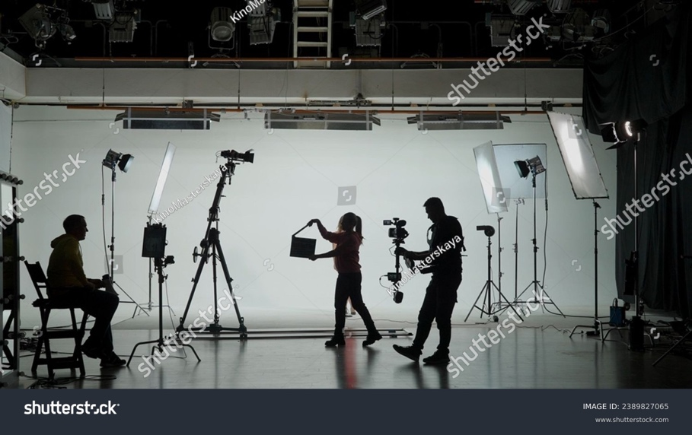
2389827065

Pivot Move
A pivot move is a camera movement that adjusts or change the viewer’s perspective while staying fixed on a tripod or a stable surface.
Pan: The camera moves horizontally left or right from a fixed position. We typically use pans to follow a subject, reveal new information or build tension.
Darjeeling Limited (2007) : In this scene, instead of relying on simple cuts, Anderson uses pans as the camera moves between characters, infusing the scene with rhythm and momentum. This approach along with his signature symmetrical framing keeps the audience engaged and enhances the visual story telling.
Psycho: (1960) Towards the end of this brutal scene, slow pan follows the blood trail, moving from Marion's lifeless face to the swirling blood going down the drain. As the camera slowly pans and dissolves into the drain, it mirrors the life draining from her body, emphasizing the finality of her death, highly effective in building emotional impact and visual symbolism. (starting at 2.02 min.)
The speed of the pan movement depends on the context of the scene and what we are trying to convey. For instance, a slow pan can build anticipation whereas a fast pan can heighten the energy of a shot.
Swish Pan (Whip pan): A very fast pan that blurs motion, creating excitement, urgency and an energetic or seamless transitions. Swish pans can also build or emphasize the relationships between characters.
Whiplash (2014) In this scene, the camera shifts between Andrew and Fletcher in sync with the music’s rhythm. The fast, blurred movement adds a surge of energy that reflects the intense drumming and sharp pace of the scene. It doesn’t merely depict tension—it makes you experience it. The whip pan directs attention back and forth between drummer Andrew and conductor Fletcher, visually highlighting their tense and confrontational dynamic. This isn’t just camera movement; it’s a deliberate, powerful exchange of control.
Tilt: The camera moves vertically up or down while remaining in a fixed position. We generally use tilts to follow action, establish scale, reveal details gradually about a character or a setting, or convey power dynamics. A tilt can give a character a sense of power by tilting up or vulnerability by tilting down. Similar to the pan, the speed of the tilt depends on the context of the scene and what we are trying to convey.
Blade Runner (2017) In both of these tilt shots in Blade Runner, the camera movement creates a visual connection between the character and their surroundings or the object they’re interacting with. These shots give us a clear sense of scale and help highlight the significance of what the character is observing or positioned near.
Dynamic Move
Dolly Shot – In a dolly shot the camera is placed on a wheeled cart, and it moves smoothly toward, away from, or alongside a subject. In dolly shots we often use tracks to ensure a controlled and fluid motion. As with every tool we use in visual storytelling, there are different reasons to use different dolly movements.
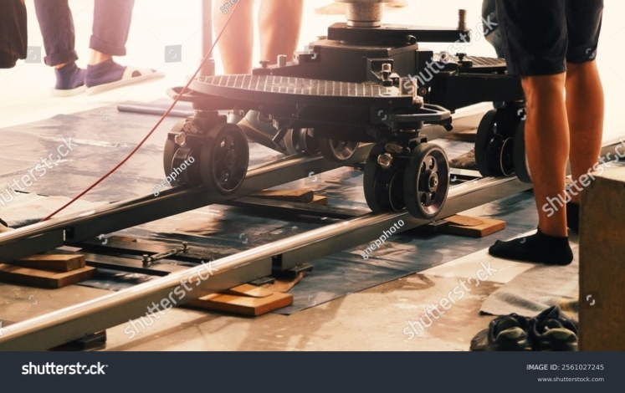
2561027245
Push in: The camera moves toward the subject or action, creating a sense of intimacy or emphasis on a specific detail. This can be about an important detail, a moment of realization or internal conflict. It heightens the dramatic tension of a scene, and it signals to the audience that what they are seeing is important.
Pull out: The camera moves away from the subject or action, often used to reveal a larger context in terms of setting or characters, give the audience a sense of detachment or abandonment or convey passage of time.
Joker (2019) The pull-out shot after the alley beating is subtle but deeply effective as it shows Arthur as small, powerless, and abandoned. It visually distances us, echoing how society has emotionally abandoned him.
The speed of movement in both of cases depends on the context of the scene and what we are trying to convey. For example, a gradual push-in can evoke a sense of intimacy or build tension, gradually pulling the audience closer to a character's emotional state and intensifying the connection. On the other hand, a swift pull-out can create a moment of sudden realization, shock, or awe, instantly altering the viewer's perspective.
Tracking/Trucking: The camera moves often to follow action or characters as they move through space, giving the audience a sense of depth and motion in the scene.
These types of shots convey a sense of fluidity, and continuity and immerse the audience in the action particularly in long takes.
Three Billboards Outside Ebbing, Missouri (2017) In this sequence, we track Officer Jason Dixon crossing the street, climbing a set of stairs, violently assaulting Red by throwing him out a window, and then calmly returning to the police station. This uninterrupted tracking shot adds intensity to what we are seeing, making the brutality feel disturbingly real, leaving no room for us to disengage or be reminded that it’s fiction.
Arc Dolly: An arc shot is a distinctive camera movement where the camera travels in a circular or semi-circular path around a subject. This type of movement can emphasize a subject's importance or create a dynamic relationship between the subject and its surroundings. Since our focus typically is centralized on the subject or subjects, these types of shots can be used to convey a sense of intimacy, heroism even panic.
The Avengers (2012) - The arc shot highlights the Avengers as a cohesive, unified team, not just separate heroes. As the camera circles around them, it visually reinforces their strength as a group, reflecting the film’s central theme of unity and teamwork. Hero shot at 1.21 min.
Boom Shot: In a boom shot the camera moves vertically up or down to reveal or conceal aspects of the scene, or to give the audience a different perspective on the subject or environment. We can use them to showcase large environments, crowd scenes, or landscapes as well as epic stories, action films or sweeping dramas. Typically, cranes, jibs or pedestals are utilized to create these shots. Even though they are similar in their utility their use depends on the scale and the budget of the production.
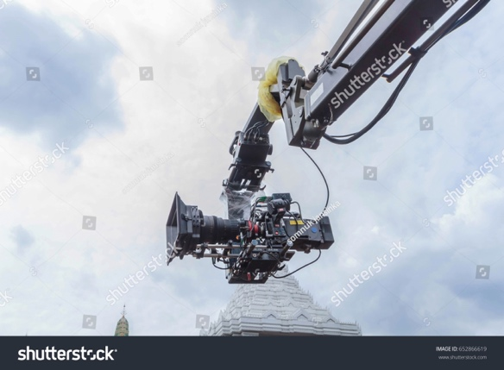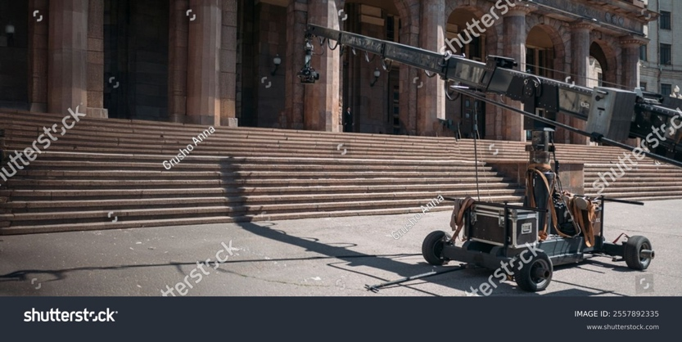
652866619 2557892335
Crane – A crane is used to move a camera vertically, horizontally, or in sweeping arcs. It consists of a long arm mounted on a pivot placed on a moveable platform, allowing for smooth, controlled movement over a large range. They are often used for grand, cinematic shots emphasizing vast settings, large crowds, or grand reveals. They can also make a character seem powerful by craning up or vulnerable by craning down.
La La Land (2016): The scene starts with a crane shot revealing the full scope of the setting and the vibrant energy of the freeway dance performance. As the sequence unfolds, the camera transitions into a Steadicam as well, weaving through the dancers
Please click on Behind the scenes to get a sense of the challenging filming process.
Jib - A jib shot is a type of camera movement where the camera is mounted on a jib arm (a small crane) that allows it to move vertically, horizontally, or in an arc with smooth motion. Jibs are often used to achieve dynamic, cinematic camera moves that would be difficult to execute with handheld or dolly setups.
Pedestal – In a pedestal shot the camera moves vertically up or down while staying on a fixed point. Unlike a tilt, a pedestal shot physically raises or lowers the camera position. We can see various examples of this in The Royal Tenenbaums directed by Wes Anderson. The movement can be used to reveal or conceal aspects of the scene, or to give the audience a different perspective on the subject or environment. And just like the jib and crane shots, we can use pedestals to enhance or diminish character presence by making them powerful or small/vulnerable.
Steadicam: A Steadicam shot is achieved using a Steadicam rig, which allows the operator to capture smooth, stable footage while moving. The rig consists of a camera stabilizer system with a harness and an articulated arm that isolates the camera from the operator's movements, reducing shakiness and creating fluid motion. Since Steadicams provide smooth, stabilized movement even when the operator is walking, running, or navigating obstacles, they offer greater freedom of movement than traditional dolly shots. This flexibility makes it possible to create immersive long takes and dynamic tracking shots that follow characters through complex spaces.
Goodfellas (1990): In this classic sequence, the camera follows Henry and Karen in one long take as they walk through the back entrance, kitchen, and into the club. Because there are no cuts, we feel like we’re right there with them with a first-person perspective of his power and influence. The smooth camera movement helps show how powerful and confident Henry is, reinforcing the glamour and excitement of his life.
In movies like Sam Mendes’s 1917 (2019) Steadicam plays a crucial role in maintaining fluid camera movement and reinforcing the illusion of a single, continuous take throughout the narrative.
Handheld: A handheld shot is where the operator holds the camera without the support of a stabilizing device like a tripod, Steadicam, or gimbal. This creates a raw, shaky, unpolished movement, adding realism, tension, or urgency to what we are seeing, creating an immersive effect, making the audience feel like they are part of the scene.
Since handheld shots allows the operator to move freely, we can have spontaneous framing and a more intimate, subjective perspective. This technique can be applied across a range of situations: in action sequences, handheld shots can heighten intensity by creating a visceral, chaotic experience, while in character-driven moments they can convey psychological unrest or emotional instability. For example, in Saving Private Ryan (1998), handheld camerawork captures the battle scenes with a documentary-like quality, adding realism and immediacy that immerse the audience in the chaos of combat.
Saving Private Ryan (1998): In this sequence, the unsteady handheld camerawork evokes a documentary aesthetic, heightening the sense of realism. The erratic motion positions the audience within the scene, making them feel as though they are experiencing the intensity and chaos of war firsthand.
Found Footage Horror can be considered a subset of Handheld camera style as it mimics amateur camerawork with mostly first-person point of view for authenticity. The Blair Witch Project (1999), which was shot entirely in a shaky, first-person point of view is one of the earlier examples of this style. Depending on how heavy or large the camera is, camera operators often use simple support tools like shoulder mounts or an Easy Rig to help reduce strain and to have better control over how much the camera shakes.
Roll shot: In a roll shot the camera rotates along its z-axis, causing the horizon line to tilt and spin. This creates a dynamic, disorienting effect, often used to heighten tension, confusion, or stylistic flair. It can range from subtle to extreme—a slight roll may create unease, while a full 360° rotation can evoke a sense of chaos or surreal disorientation. Commonly used in dream sequences, action films, horror, or sci-fi to simulate dizziness, loss of control, or altered perception.
Inception (2010) – In Inception, director Christopher Nolan and cinematographer Wally Pfister, use the roll shot in the rotating hallway fight scene where Joseph Gordon-Levitt’s character fights in a gravity-shifting corridor that reinforces the film’s theme of shifting realities, making the audience feel as if they’re experiencing the dream world’s instability.
Please click on Behind the Scenes at 4.27min. to get a better sense of how this effect was achieved in Inception.
Black Panther (2018) – In Killmonger’s throne room scene, a slow roll shot is used to reflect his rise to power and the shift in control. The scene begins with the world literally turned upside down, and as he takes his seat, the camera slowly rotates upright, symbolizing his claim to the throne and his mission to reshape the world. This powerful visual reflects the complexity of his character: seen as a villain driven by aggression and power, yet also as someone deeply motivated by injustice, trying to correct what he believes is wrong.
We can create a roll shot effect in several ways: by rotating a handheld or gimbal-mounted camera, using a Steadicam with roll-axis control, or even a subtle roll by slowly tilting the camera on a fluid head tripod with a dutch-angle effect.
Vertigo Shot (Dolly/Zoom): In a vertigo shot we dolly in or dolly out while simultaneously zooming in or out in the opposite direction. This technique produces a surreal effect: the subject remains the same size in the frame while the background appears to expand when zooming out while dollying in, or contract when zooming in while dollying out. The effect works best when the zoom speed is carefully matched to the dolly movement. It is a powerful tool for storytelling as it can capture the shock of sudden realization, build an atmosphere of dread or unease, or convey a character’s disconnection from their world. Since it bends reality itself, it can also transport us into the surreal, heightening dreamlike or otherworldly moments.
Vertigo (1958) – This is the first major use of dolly/zoom, representing the character’s acrophobia or fear of heights.
Bohemian Rhapsody: In this concert scene, we watch Freddie Mercury’s bond with the audience grow. As the scene goes on, the crowd appears larger and moves closer to him while he stays the same size, highlighting his powerful connection with them.
In the end, camera movement is far more than a technical decision—it is a storytelling device that forges a powerful bond between audience and story. By choosing and executing movement with intention, we shape the emotional tone of a scene, guide the audience’s response, and draw them deeper into the lives of the characters and the unfolding narrative.
Please click on the Additional clip link to further review camera movement.
Making It Work: Creative Camera Techniques on a Student Budget
While student productions may not always have access to the specialized equipment, creative adaptation can go a long way. By making the most of the tools at hand, we can create similar effects and bring dynamic movement into our storytelling.
Here are a couple of examples:
Tripod Boom Method: Extend a sturdy tripod and use it like a mini-jib, holding one leg while tilting the camera up or down. For smoother motion try using a counterweight like a sandbag on the opposite leg. We can use this for small-scale vertical reveals such as from feet to face.
Another method is to extend a sturdy tripod to its highest point and tilting it up or down smoothly while panning. We can use this for short jib movements and reveals.
Monopod as a Mini Jib: Attach a camera to a monopod and raise/lower it in a controlled arc. For added stability, use a counterweight a sandbag or water bottle attached to the bottom.
Works well for small-scale crane movements such as revealing objects on a table.
Gimbal + Handheld Lift: If we have access to a gimbal, we can use it to lift the camera vertically while walking smoothly. This can mimic a jib-up or jib-down effect while keeping the shot steady. We can create fluid, floating camera effects, especially when tracking a character and we can add slow-motion for extra smoothness.
C-Stand or Boom Pole: We can mount a lightweight camera on a C-stand arm or boom mic pole and raise/lower it carefully.
Ladder or Chair Lift: Have a steady-handed operator stand on a ladder and smoothly tilt up or down. For a moving jib effect, use a rolling chair. Start tight on the ground and jib up to unveil a grand setting. This works well in establishing shots such as revealing a location or a crowded scene.
Tripod
Even though our primary focus in this chapter is camera movement. We need to also go over key components of a tripod as it helps stabilize and control the camera for smooth and precise shots.
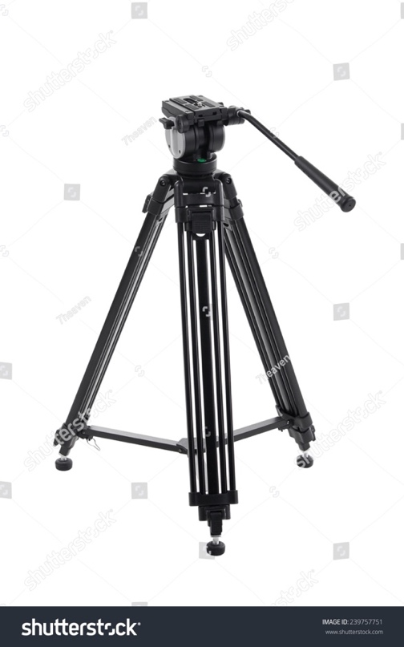
239757751
Here’s a breakdown of the main parts of a tripod:
1. Tripod Head (Controls camera movement)
• Fluid Head – The most common type for filmmaking, allowing smooth pan and tilt motions.
• Pan Handle(s) – Long handles extending from the tripod head, used to control panning and tilting smoothly.
• Quick Release Plate – A detachable plate that mounts the camera to the tripod for quick setup and removal.
• Tilt Lock & Pan Lock – Locks the tilt and pan movements in place when needed.
• Counterbalance System – Helps maintain stability, especially for heavier cameras.
2. Tripod Legs (Supports the camera)
• Leg Sections – Usually adjustable in 2-3 segments, allowing height customization.
• Leg Locks – Twist locks or flip locks that secure the leg height in place.
• Spreader – A support structure (mid-level or ground) that keeps legs evenly spaced and stable.
• Rubber Feet / Spikes – Rubber grips for indoor surfaces; retractable spikes for outdoor use.
3. Center Column / Bowl Mount (Adjusts height and leveling)
• Center Column – Some tripods have an adjustable central post for additional height control.
• Bowl Mount – A leveling mechanism (usually 75mm or 100mm diameter) allowing quick camera leveling without adjusting the legs.
• Leveling Bubble – A small spirit/bubble level for accurate horizontal alignment.
4. Additional Accessories
• Dolly Wheels – Attach to the tripod legs for smooth rolling movement.
• Weight Hook – A hook at the bottom of the center column to add weight for extra stability.
Choosing the Right Tripod for Filmmaking
• Lightweight tripods (mechanical/frictional) – Good for run-and-gun shooting but less stable, most of them not practical and smooth for pans and tilts.
• Heavy-duty tripods (gear heads)– Exceptionally smooth, best for cinema cameras and controlled studio setups.
• Fluid head tripods – Essential for smooth cinematic pans and tilts.

CHAPTER SUMMARY
Static vs. Moving Shots
• Static shots (e.g., tripod-mounted) focus attention on composition and performance. Used in scenes requiring emotional subtlety or precise blocking.
Example: Wes Anderson’s symmetrical frames or tense dialogue scenes in No Country for Old Men.
• Moving shots provide immersion, shift perspective, and guide audience focus. These can reflect emotion, momentum, or narrative shifts.
Types of Camera Movements and Their Storytelling Impact
Pivot-Based Movements
Pan (horizontal movement)
Used to follow action, reveal space, or shift perspective.
Example: The Darjeeling Limited uses pans instead of cuts to maintain rhythm and flow between characters.
Tilt (vertical movement)
Used to reveal vertical space, suggest scale, or show dominance/vulnerability.
Example: In Blade Runner 2049, tilt shots connect characters with towering environments, reinforcing their isolation or insignificance.
Whip Pan / Swish Pan
A rapid pan that creates blur and urgency, often used to build intensity or make energetic transitions.
Example: Whiplash uses whip pans in rehearsal scenes to visually capture the intensity and competitive tension between characters.
Dynamic Movements (Camera physically travels through space)
Dolly Camera is placed on a wheeled cart, and it moves smoothly toward, away from, or alongside a subject
• Push-In
Camera moves closer to the subject, often used to emphasize realization, intimacy, or tension.
Example: A slow push-in can signal a character’s internal shift or emotional moment.
• Pull-Out
Camera moves away from the subject to reveal isolation, broader context, or a change in emotional distance.
Example: In Joker, after Arthur is beaten in the alley, the pull-out highlights his isolation and society’s indifference.
Tracking / Trucking Shot
Camera follows a character’s movement, creating immersion and continuity.
Example: Three Billboards Outside Ebbing, Missouri features a long take tracking Officer Dixon across multiple locations, intensifying the brutality of the scene by refusing to cut.
Arc Shot
Camera circles around a subject to emphasize importance, unity, or emotional momentum.
Example: The Avengers uses an arc shot to unify the team visually and thematically.
Boom / Crane / Jib Shot
These elevate the camera to provide dramatic reveals or large-scale perspectives.
Example: La La Land opens with a sweeping crane shot that introduces the setting and energy of the freeway musical number before transitioning to Steadicam for more intimate movement.
Pedestal Shot
Camera is raised or lowered in a straight vertical line—useful for subtle reveals or perspective shifts, often used in controlled, studio environments.
Specialty Movements
Roll Shot
Rotates the camera along the z-axis, disorienting the viewer.
Example: In Black Panther, Killmonger’s throne room scene begins upside down and slowly rotates upright, symbolizing his shift in power and ideology.
Vertigo Shot (Dolly Zoom)
Combines dolly movement with an opposite zoom to create spatial distortion, reflecting psychological tension.
Example: Vertigo (1958) pioneered this to represent fear of heights; Bohemian Rhapsody uses it to show Freddie Mercury’s growing bond with the audience.
Handheld and Stabilized Movement
Steadicam
Offers smooth movement with more flexibility than a dolly. Often used in long takes, tracking characters through environments while maintaining a stable image.
Example: Goodfellas features an iconic Steadicam shot as Henry Hill takes Karen through the back entrance of the Copacabana—immersing us in his world.
Handheld Camera
Creates a raw, spontaneous, and intimate feel. Shakiness adds realism, often used in war films, horror, or emotional scenes.
Example: Saving Private Ryan uses handheld shots to mimic documentary-style combat footage, pulling the viewer directly into the chaos of battle.
Found Footage Style
A subgenre of handheld cinematography used in films like The Blair Witch Project to create authenticity through a first-person point of view.
Making It Work on a Student Budget
Professional tools like cranes and Steadicams may be beyond the reach of student productions, but similar effects can be achieved with creativity and resourcefulness:
• Tripod Boom Method – Extend and pivot a tripod for basic crane-like moves.
• Monopod Mini-Jib – Use a monopod with a counterweight for controlled lifts.
• Rolling Chair / Ladder – Create vertical motion by moving or elevating the camera.
• Gimbal Lift – Use gimbals for stabilized floating movement and vertical tracking.
• Boom Pole Mount – Use a C-stand or boom pole to simulate high-angle shots.
The goal is to match the intention of professional tools, not to replicate them exactly—creative execution matters more than expensive gear.
Tripod Fundamentals
Tripods are essential for stable shots and controlled movement.
Components:
1. Tripod Head – Controls panning and tilting.
o Fluid Head for smooth motion.
o Pan Handles for directional control.
o Quick Release Plate for fast camera attachment.
o Tilt/Pan Locks to hold position.
o Counterbalance System for heavy rigs.
2. Legs and Spreader – Provide height, stability, and flexibility.
o Adjustable legs with flip or twist locks.
o Rubber feet or spikes depending on terrain.
o Spreaders stabilize the structure.
3. Center Column / Bowl Mount
o Bowl Mount allows quick leveling.
o Leveling Bubble ensures horizontal framing.
4. Optional Accessories
o Dolly wheels for rolling camera moves.
o Weight hooks for extra stability in windy or uneven conditions.
Conclusion
Understanding camera movement is not simply a technical detail—it is a powerful visual storytelling tool. With every type of movement—from subtle pans to dramatic crane shots—we can guide viewer attention, shape emotion, enhance tension, and contribute to the rhythm and flow of a film.

CHAPTER APPLICATION
Review and Demonstrate What You Know
MASTERING CAMERA MOVEMENT IN VISUAL STORYTELLING
Objective: In this chapter Application, students will plan, shoot, and edit a short scene incorporating multiple camera movements to enhance storytelling and visual engagement.
1. Concept & Pre-Production (Planning Stage)
Choose a Scenario (or create your own):
• Tension Build-Up: A character is being followed, using different movements to create suspense.
• Emotional Shift: A character experiences a realization or transformation, with camera movement reflecting their internal change.
• Dynamic Action Scene: A chase, confrontation, or dramatic event where movement keeps the energy high.
• Character Introduction: Use a combination of movements to establish who they are and their surroundings.
Storyboard the Shots:
• Plan at least 5 distinct camera movements (see the list below).
• Indicate how each movement adds emotion, meaning, or pacing to the scene.
2. Production (Filming Stage)
Incorporate These Camera Movements:
1. Pan - Horizontal pivot to follow action or reveal information.
2. Tilt – Vertical pivot to follow action or reveal information..`
3. Tracking Shot – Follow a character as smoothly as possible.
4. Handheld Shot – Introduce raw energy or intensity.
5. Push-In or Pull-Out – Move closer to intensify emotion or back out to create distance.

Requirements:
• The scene must flow naturally with motivated camera movements (not just random movement).
• Each movement should contribute to storytelling and character emotions.
3. Post-Production (Editing & Submission)
Edit the Scene Together
• Use transitions and pacing to enhance the movement.
• Add sound design/music to strengthen the impact of each shot.
Final Submission:
• Export a 60-90 second scene featuring all camera movements.
• Write a brief reflection (5-7 sentences) explaining how the camera movements helped tell the story and added emotion.
Bonus Challenge
Students can attempt a one-take sequence incorporating multiple movements or experiment with a hidden cut to simulate a continuous shot.

CHAPTER QUIZ
Evaluate Your Understanding of Key Topics
Multiple Choice
1.What is the primary visual effect of a pull-out shot?
A. It builds tension by zooming into a character’s eyes
B. It creates a sense of closeness and emotional intimacy
C. It reveals broader context or isolation by moving away
D. It distorts perspective through lens manipulation
Answer: C
2. Which of the following horizontal movement is used to follow action, reveal space, or shift perspective?
A. Tilt
B. Vertigo shot
C. Roll shot
D. Pan
Answer: D
3. Which camera movement best conveys disorientation or psychological imbalance?
A. Dolly-in
B. Pedestal
C. Roll shot
D. Pan
Answer: C
4.What is one key advantage of a static shot?
A. Greater sense of motion and urgency
B. Emphasizes chaos and realism
C. Provides control over framing and performance focus
D. Follows characters dynamically through space
Answer: C
5.In the film Whiplash, what function does the whip pan serve during the rehearsal scenes?
A. Introduces a new character
B. Enhances the emotional rhythm of the scene
C. Creates comedic timing
D. Replaces a tracking shot
Answer: B
True / False
6. A Steadicam combines the flexibility of handheld shots with the smoothness of a dolly.
True
7. A tilt shot can be used to suggest a character’s power or vulnerability.
True
8. The vertigo shot combines dolly movement with an opposite zoom to create spatial distortion, which can reflect psychological tension
True
9. Steadicam shots allow operators to create handheld camera effects with added shakiness.
False

Short Answer
10. Name two creative ways students can simulate boom or jib shots without expensive equipment.
Sample Answer: Tripod boom method, monopod with counterweight, gimbal handheld lift, or C-stand with camera rig.
11. Describe how the arc shot in The Avengers contributes to the storytelling of the team dynamic.
Sample Answer: The arc shot rotates around the group to visually show the team as a united front, emphasizing cohesion and collective strength rather than individual power.
12. Why is the long tracking shot in Three Billboards Outside Ebbing, Missouri so effective in creating emotional impact?
Sample Answer: The uninterrupted take builds intensity and realism, making the violence feel more immediate and leaving the audience no space to emotionally distance themselves.
16. What is the difference between a pan and a swish (whip) pan? When might you use each one?
Sample Answer: A pan is a slow, controlled horizontal movement used to follow action or reveal information. A swish pan is much faster and blurrier, used to create urgency, tension, or rhythmic energy, often in fast-paced or stylized sequences.

